

**MPLS LAB**

Brendon Ahn | Advanced Cisco | 2022-2023



**Purpose:**

To configure MPLS on switches to ping between 4 networks

**Background:**

MPLS is multi-protocol label switching. The idea of label switching was first introduced in 1996 by Ipsilon Networks called flow management protocol, however it did not do well in the market. Later Cisco developed TDP or tag distribution protocol, this was later renamed to Label Switching. The Internet Engineering Task Force later made Label Switching non-proprietary and open source.

What MPLS does is route shortest path first using labels rather than addresses. Essentially it puts a tag on all your routes and chooses the most efficient was to send packets that way. Depending on your network this could be faster or the same, its hard to tell. You can do MPLS on switches and routers.

For this lab we set up OSPF routes and added MPLS to our switches. This process only takes two additional commands, MPLS IP and MPLS Label Protocol LDP. The rest of the configurations are simply just setting up OSPF as you would normally. To do 4 networks instead of 2 with just 2 end machines we set up loopbacks on our routers to do the pings and to be pinged.

MPLS can be really useful to businesses as it is a fast-switching method allowing traffic from a big network to router more efficiently. The more traffic a network has the more useful MPLS will be. The table can also be automatically updated making the method require less maintenance overall. A downside is that it can be more expensive, and it doesn’t provide encryption. If you already have strong security this isn’t really a downside as it is private traffic so someone with bad intentions would have to hack into your network first. Other benefits include more bandwidth, less traffic congestion, and better end user experience.

MPLS has been a tried-and-true protocol for the last decade but is competing with other things like SD-Wan. It is possible to do a hybrid, and companies that already spent money on MPLS are likely to continue to use it as it is still reliable.

**Lab Summary:**

We set up MPLS on 3 switches and 2 routers to be able to ping between 4 networks efficiently.

**Topology:**

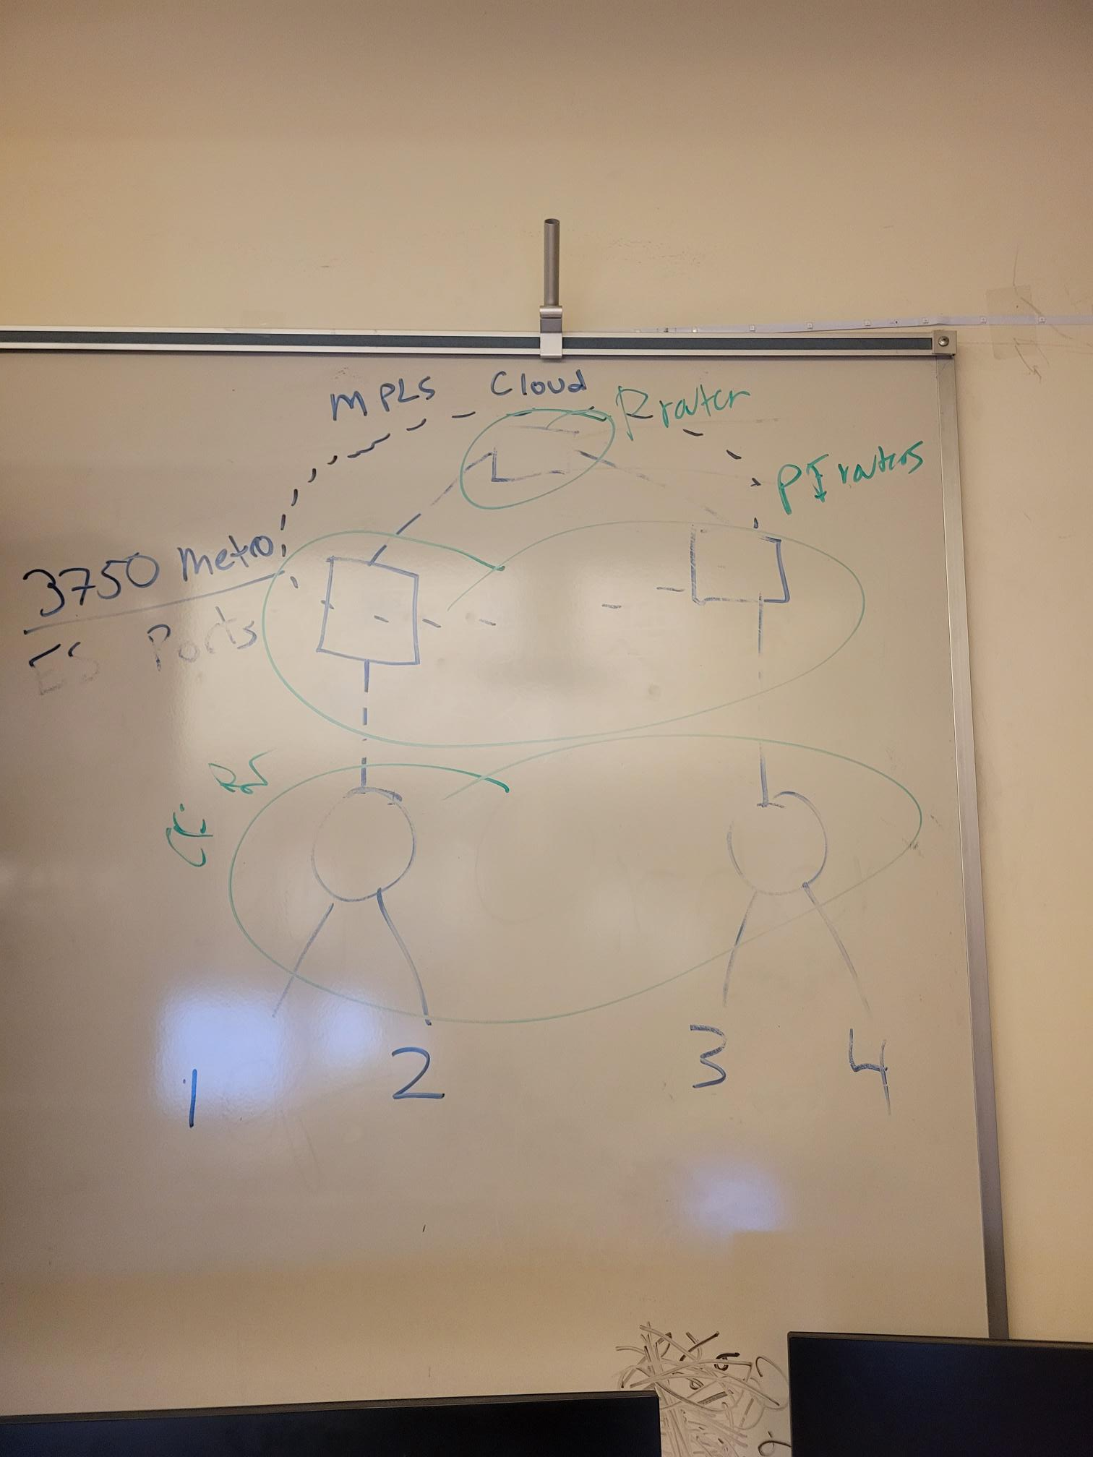

**New Commands:**

MPLS IP

* Enables MPLS Traffic

MPLS Label Protocol LDP

* Enables LDP which assigns labels

**Lab Procedure:**

**Router 1:**

Current configuration : 1491 bytes

!

! Last configuration change at 20:53:13 UTC Fri Jun 2 2023

!

version 15.5

service timestamps debug datetime msec

service timestamps log datetime msec

no platform punt-keepalive disable-kernel-core

!

hostname R1

!

boot-start-marker

boot-end-marker

!

vrf definition Mgmt-intf

!

address-family ipv4

exit-address-family

!

address-family ipv6

exit-address-family

!

no aaa new-model

!

subscriber templating

vtp domain cisco

vtp mode transparent

multilink bundle-name authenticated

!

license udi pid ISR4321/K9 sn FDO214421CF

!

spanning-tree extend system-id

!

redundancy

mode none

!

vlan internal allocation policy ascending

!

vlan 2,10,20

!

vlan 996

name CUSTOMER_NATIVE

!

interface Loopback0

ip address 10.10.0.1 255.255.255.0

!

interface GigabitEthernet0/0/0

ip address 10.10.1.1 255.255.255.0

negotiation auto

!

interface GigabitEthernet0/0/1

ip address 10.10.2.1 255.255.255.0

negotiation auto

!

interface Serial0/1/0

no ip address

shutdown

!

interface Serial0/1/1

no ip address

shutdown

!

interface GigabitEthernet0

vrf forwarding Mgmt-intf

no ip address

shutdown

negotiation auto

!

interface Vlan1

no ip address

!

router ospf 1

router-id 1.1.1.1

network 10.10.0.0 0.0.255.255 area 1

!

ip forward-protocol nd

no ip http server

no ip http secure-server

ip tftp source-interface GigabitEthernet0

!

control-plane

!

line con 0

stopbits 1

line aux 0

stopbits 1

line vty 0 4

login

!

End

**Switch 2:**

Building configuration...

Current configuration : 3586 bytes

!

! Last configuration change at 06:42:00 UTC Mon Mar 1 1993

!

version 12.2

no service pad

service timestamps debug datetime msec

service timestamps log datetime msec

no service password-encryption

!

hostname Switch

!

boot-start-marker

boot-end-marker

!

no aaa new-model

system mtu routing 1500

ip routing

!

vtp domain cisco

vtp mode transparent

!

mpls label protocol ldp

!

crypto pki trustpoint TP-self-signed-3180753792

enrollment selfsigned

subject-name cn=IOS-Self-Signed-Certificate-3180753792

revocation-check none

rsakeypair TP-self-signed-3180753792

!

crypto pki certificate chain TP-self-signed-3180753792

certificate self-signed 01

3082023E 308201A7 A0030201 02020101 300D0609 2A864886 F70D0101 04050030

31312F30 2D060355 04031326 494F532D 53656C66 2D536967 6E65642D 43657274

69666963 6174652D 33313830 37353337 3932301E 170D3933 30333031 30363237

35335A17 0D323030 31303130 30303030 305A3031 312F302D 06035504 03132649

4F532D53 656C662D 5369676E 65642D43 65727469 66696361 74652D33 31383037

35333739 3230819F 300D0609 2A864886 F70D0101 01050003 818D0030 81890281

8100A334 3E4304F6 BAB68601 D9A55BA4 0898A0D3 8D6A82A4 65BE961E 6C85AC95

2DC4532A 706862C1 D1C659E0 B901D856 80C9E308 65D10954 BE74FB7E 4A226029

415336FF C1426961 13DE2D5D 5D1DC511 17283CE7 BAC499D7 2763EC77 280A11F3

B01EEC85 1192D3C3 2C709C5B 8F373BD1 9DE67197 4492C07B 1C21DDC4 3BFFB73D

C00B0203 010001A3 66306430 0F060355 1D130101 FF040530 030101FF 30110603

551D1104 0A300882 06537769 74636830 1F060355 1D230418 30168014 62DE0870

F1B30250 A1F39293 9EFB7884 1179817B 301D0603 551D0E04 16041462 DE0870F1

B30250A1 F392939E FB788411 79817B30 0D06092A 864886F7 0D010104 05000381

8100533E DE8FD401 9E7739C7 2F4FD50A 584DBF46 1CE5EDFD CA1176AF 62B67B13

BCDC9E03 B2B7DB3D 4DEE60F0 76390004 5600AE14 199055A1 58A595D7 4ED576D0

1B5DF9F3 F9B3F7C4 F54CB479 9BB3DACD 0BF1255C B1C52B19 030674CA 3926DC60

CE4BBDC7 25003695 D79B1CF9 CC1C2788 3812DAD9 0A807A5E 94D70C03 A11521FA 9EEC

quit

spanning-tree mode pvst

spanning-tree extend system-id

!

vlan internal allocation policy ascending

!

vlan 2

name Data

!

vlan 3

!

vlan 10

name ten

!

vlan 20

name twenty

!

vlan 30

name thirty

!

vlan 40

name forty

!

vlan 100

!

vlan 996

name CUSTOMER_NATIVE

!

interface FastEthernet1/0/1

no switchport

ip address 10.10.2.2 255.255.255.0

!

interface FastEthernet1/0/2

!

interface FastEthernet1/0/3

!

interface FastEthernet1/0/4

!

interface FastEthernet1/0/5

!

interface FastEthernet1/0/6

!

interface FastEthernet1/0/7

!

interface FastEthernet1/0/8

!

interface FastEthernet1/0/9

!

interface FastEthernet1/0/10

!

interface FastEthernet1/0/11

!

interface FastEthernet1/0/12

!

interface FastEthernet1/0/13

!

interface FastEthernet1/0/14

!

interface FastEthernet1/0/15

!

interface FastEthernet1/0/16

!

interface FastEthernet1/0/17

!

interface FastEthernet1/0/18

!

interface FastEthernet1/0/19

!

interface FastEthernet1/0/20

!

interface FastEthernet1/0/21

!

interface FastEthernet1/0/22

!

interface FastEthernet1/0/23

!

interface FastEthernet1/0/24

!

interface GigabitEthernet1/0/1

!

interface GigabitEthernet1/0/2

!

interface GigabitEthernet1/1/1

!

interface GigabitEthernet1/1/2

no switchport

ip address 10.10.3.1 255.255.255.0

speed auto 1000

mpls label protocol ldp

mpls ip

!

interface Vlan1

no ip address

!

router ospf 1

router-id 2.2.2.2

network 10.10.2.0 0.0.0.255 area 1

network 10.10.3.0 0.0.0.255 area 1

!

ip http server

ip http secure-server

!

logging esm config

!

line con 0

line vty 0 4

login

line vty 5 15

login

!

end

**Switch 3:**

Current configuration : 3654 bytes

!

! Last configuration change at 00:02:32 UTC Mon Mar 1 1993

!

version 12.2

no service pad

service timestamps debug datetime msec

service timestamps log datetime msec

no service password-encryption

!

hostname Switch

!

boot-start-marker

boot-end-marker

!

no aaa new-model

system mtu routing 1500

ip routing

!

--More--

*Mar 1 00:03:44.579: %OSPF-4-ERRRCV: Received invalid packet: mismatch area ID, from backbone area must be virtual-link but not found from 10.1.0.1, GigabitEthvtp domain CCNP

vtp mode transparent

!

mpls label protocol ldp

!

crypto pki trustpoint TP-self-signed-1928519808

enrollment selfsigned

subject-name cn=IOS-Self-Signed-Certificate-1928519808

revocation-check none

rsakeypair TP-self-signed-1928519808

!

crypto pki certificate chain TP-self-signed-1928519808

certificate self-signed 01

3082023E 308201A7 A0030201 02020101 300D0609 2A864886 F70D0101 04050030

31312F30 2D060355 04031326 494F532D 53656C66 2D536967 6E65642D 43657274

69666963 6174652D 31393238 35313938 3038301E 170D3933 30333031 30303032

33315A17 0D323030 31303130 30303030 305A3031 312F302D 06035504 03132649

4F532D53 656C662D 5369676E 65642D43 65727469 66696361 74652D31 39323835

31393830 3830819F 300D0609 2A864886 F70D0101 01050003 818D0030 81890281

81008B30 3A153E0F C5337EE5 8C04903C 1D662C11 67BCB849 1FD4F4A7 473B8B9B

83EF3ACD FE4B110A DD76282F 4E30A4B5 46C5C5D1 A124B0D2 82225B01 2BDB3C9C

9C09615A 1F9D91DE 4DB6157E 8A876211 5D474776 B1B4AB30 6F66021C 4200E036

1E929B86 4FA88CBA 94015E46 6BDD0606 BFAA6DF8 2CB9B405 C6C9FA91 52F17004

DD4B0203 010001A3 66306430 0F060355 1D130101 FF040530 030101FF 30110603

551D1104 0A300882 06537769 74636830 1F060355 1D230418 30168014 E4072F2C

109D5419 763AF1F6 3402BEBC F64C1D58 301D0603 551D0E04 160414E4 072F2C10

9D541976 3AF1F634 02BEBCF6 4C1D5830 0D06092A 864886F7 0D010104 05000381

810030EB 2B3CC0CA 74DDFBCF 77C117FA A188B26D 8C337B44 778ABA01 875C9FFE

240BAF7D 0E87030B A5AEA66F 6E594AC2 FABC4039 11523E42 3E2CCDCB 5183AAB5

893976B6 06C97D18 B1619F51 0A8D2EB0 E7C949E8 B1FC64B6 D00C9718 4026EDAE

825A940D 28A6947E C76FEAC6 9881BE64 E661808B 921B1C5F C87F8D11 BD031341 1268

quit

spanning-tree mode pvst

spanning-tree extend system-id

!

vlan internal allocation policy ascending

!

vlan 2

name forleft

!

vlan 3

name forright

!

vlan 10

name voice

!

vlan 20

name data

!

vlan 30

name Expedia

!

vlan 40

name forty

!

vlan 100

!

vlan 996

name CUSTOMER_NATIVE

!

interface FastEthernet1/0/1

!

interface FastEthernet1/0/2

!

interface FastEthernet1/0/3

!

interface FastEthernet1/0/4

!

interface FastEthernet1/0/5

!

interface FastEthernet1/0/6

!

interface FastEthernet1/0/7

!

interface FastEthernet1/0/8

!

interface FastEthernet1/0/9

!

interface FastEthernet1/0/10

!

interface FastEthernet1/0/11

!

interface FastEthernet1/0/12

!

interface FastEthernet1/0/13

!

interface FastEthernet1/0/14

!

interface FastEthernet1/0/15

!

interface FastEthernet1/0/16

!

interface FastEthernet1/0/17

!

interface FastEthernet1/0/18

!

interface FastEthernet1/0/19

!

interface FastEthernet1/0/20

!

interface FastEthernet1/0/21

!

interface FastEthernet1/0/22

!

interface FastEthernet1/0/23

!

interface FastEthernet1/0/24

!

interface GigabitEthernet1/0/1

!

interface GigabitEthernet1/0/2

!

interface GigabitEthernet1/1/1

no switchport

ip address 10.10.3.2 255.255.255.0

speed auto 1000

mpls label protocol ldp

mpls ip

!

interface GigabitEthernet1/1/2

no switchport

ip address 10.10.4.1 255.255.255.0

speed auto 1000

mpls label protocol ldp

mpls ip

!

interface Vlan1

no ip address

!

router ospf 1

router-id 4.4.4.4

network 10.10.3.0 0.0.0.255 area 1

network 10.10.4.0 0.0.0.255 area 1

!

ip http server

ip http secure-server

!

logging esm config

!

line con 0

line vty 0 4

login

line vty 5 15

login

!

end

**Switch 4:**

Building configuration...

Current configuration : 3606 bytes

!

! Last configuration change at 06:34:14 UTC Mon Mar 1 1993

!

version 12.2

no service pad

service timestamps debug datetime msec

service timestamps log datetime msec

no service password-encryption

!

hostname Switch

!

boot-start-marker

boot-end-marker

!

no aaa new-model

system mtu routing 1500

ip routing

!

vtp domain CCNP

vtp mode transparent

!

crypto pki trustpoint TP-self-signed-2132837760

enrollment selfsigned

subject-name cn=IOS-Self-Signed-Certificate-2132837760

revocation-check none

rsakeypair TP-self-signed-2132837760

!

crypto pki certificate chain TP-self-signed-2132837760

certificate self-signed 01

3082023E 308201A7 A0030201 02020101 300D0609 2A864886 F70D0101 04050030

31312F30 2D060355 04031326 494F532D 53656C66 2D536967 6E65642D 43657274

69666963 6174652D 32313332 38333737 3630301E 170D3933 30333031 30363334

30385A17 0D323030 31303130 30303030 305A3031 312F302D 06035504 03132649

4F532D53 656C662D 5369676E 65642D43 65727469 66696361 74652D32 31333238

33373736 3030819F 300D0609 2A864886 F70D0101 01050003 818D0030 81890281

8100ADCD DC0A872F 1D00A2DA 644C99D2 E06C10A1 B34FD063 C2FE762E 8664908A

08CBBE96 8F31ED10 E500CF03 AB42E811 404C3359 5DA36756 0FF1E5A2 85800C7B

53D01E4B FE9DBDFD 61217E87 3AB1F9DA F63A10E9 17E1E02F 453A0056 0D6D1AEB

FF6A8C6B B57CAA6E 9601DFFB 46764513 3051F717 10604811 16E62FC6 9CEBD99A

AC890203 010001A3 66306430 0F060355 1D130101 FF040530 030101FF 30110603

551D1104 0A300882 06537769 74636830 1F060355 1D230418 30168014 FC8735F1

2DF7B880 244FC03B C33D66D6 7A073FB2 301D0603 551D0E04 160414FC 8735F12D

F7B88024 4FC03BC3 3D66D67A 073FB230 0D06092A 864886F7 0D010104 05000381

810074FD 4CEFBCC6 E11057DF E613FA7D 9766DFD4 38D3F314 DB32423A 9CC16717

A710E8CB DAC97243 28C72A19 C9131FD9 8E00C847 AD3B5A63 DB4BB8AD D125B75E

51A7BC91 08757B48 FA24D77F 304BC0B3 DDC0C28D EC2F54A9 1EFAAA49 6CB13EA1

B17754AA 5C4ED68D AF6C7BB3 371841DE 20F1240C 307E5EDA 4864E422 D8F5105B 9599

quit

spanning-tree mode pvst

spanning-tree extend system-id

!

vlan internal allocation policy ascending

!

vlan 2

name forleft

!

vlan 3

name forright

!

vlan 4

!

vlan 10

name BGP

!

vlan 20

name EIGRP

!

vlan 30

name Expedia

!

vlan 100

!

vlan 996

name CUSTOMER_NATIVE

!

interface FastEthernet1/0/1

no switchport

no ip address

shutdown

!

interface FastEthernet1/0/2

no switchport

ip address 10.10.5.1 255.255.255.0

!

interface FastEthernet1/0/3

!

interface FastEthernet1/0/4

!

interface FastEthernet1/0/5

!

interface FastEthernet1/0/6

!

interface FastEthernet1/0/7

!

interface FastEthernet1/0/8

!

interface FastEthernet1/0/9

!

interface FastEthernet1/0/10

!

interface FastEthernet1/0/11

!

interface FastEthernet1/0/12

!

interface FastEthernet1/0/13

!

interface FastEthernet1/0/14

!

interface FastEthernet1/0/15

!

interface FastEthernet1/0/16

!

interface FastEthernet1/0/17

!

interface FastEthernet1/0/18

!

interface FastEthernet1/0/19

!

interface FastEthernet1/0/20

!

interface FastEthernet1/0/21

!

interface FastEthernet1/0/22

!

interface FastEthernet1/0/23

!

interface FastEthernet1/0/24

!

interface GigabitEthernet1/0/1

!

interface GigabitEthernet1/0/2

!

interface GigabitEthernet1/1/1

!

interface GigabitEthernet1/1/2

no switchport

ip address 10.10.4.2 255.255.255.0

speed auto 1000

mpls label protocol ldp

mpls ip

!

interface Vlan1

no ip address

!

router ospf 1

router-id 5.5.5.5

network 10.10.4.0 0.0.0.255 area 1

network 10.10.5.0 0.0.0.255 area 1

!

ip http server

ip http secure-server

!

logging esm config

!

line con 0

line vty 0 4

login

line vty 5 15

login

!

end

**Router 5:**

Building configuration...

Current configuration : 1637 bytes

!

! Last configuration change at 21:42:07 UTC Tue May 30 2023

!

version 15.5

service timestamps debug datetime msec

service timestamps log datetime msec

no platform punt-keepalive disable-kernel-core

!

hostname R5

!

boot-start-marker

boot-end-marker

!

vrf definition Mgmt-intf

!

address-family ipv4

exit-address-family

!

address-family ipv6

exit-address-family

!

no aaa new-model

!

subscriber templating

multilink bundle-name authenticated

!

license udi pid ISR4321/K9 sn FDO214913GF

!

spanning-tree extend system-id

!

redundancy

mode none

!

vlan internal allocation policy ascending

!

interface Loopback0

ip address 10.10.7.1 255.255.255.0

!

interface GigabitEthernet0/0/0

ip address 10.10.5.2 255.255.255.0

negotiation auto

!

interface GigabitEthernet0/0/1

ip address 10.10.6.1 255.255.255.0

negotiation auto

!

interface Serial0/1/0

no ip address

shutdown

!

interface Serial0/1/1

no ip address

shutdown

!

interface GigabitEthernet0/2/0

no ip address

shutdown

negotiation auto

!

interface GigabitEthernet0/2/1

no ip address

shutdown

negotiation auto

!

interface GigabitEthernet0

vrf forwarding Mgmt-intf

no ip address

shutdown

negotiation auto

!

interface Vlan1

no ip address

shutdown

!

router ospf 1

router-id 6.6.6.6

network 10.10.5.0 0.0.0.255 area 1

network 10.10.6.0 0.0.0.255 area 1

network 10.10.7.0 0.0.0.255 area 1

!

ip forward-protocol nd

no ip http server

no ip http secure-server

ip tftp source-interface GigabitEthernet0

!

control-plane

!

line con 0

stopbits 1

line aux 0

stopbits 1

line vty 0 4

login

!

!

end

**Problems:**

We had a lot of layer 1 issues with certain ethernet cables not working and not being able to connect our pcs to routers. We also had an issue where we couldn’t console into anything. We also at some point had ethernet cables going to wrong points. On top of this our network design was a little bit off which prevented us from being able ping the end users all though the loopback pings all worked. Although most the issues were layer 1, majority of these got fixed simply by using a different rack instead.

**Conclusion:**

We learned how to set up MPLS on 3 switches and 2 routers to be able to ping between 4 networks efficiently, as well as learning to maneuver around Catalyst 3750 switches which can be quite different and require additional commands to configure ports.